**Hotel Reservation Analysis with SQL**

In this Project, we will use SQL to answer the questions related to the dataset.

**Dataset Details:**

The dataset includes the following columns:

**Booking_ID:** A unique identifier for each hotel reservation.

**no_of_adults:** The number of adults in the reservation.

**no_of_children:** The number of children in the reservation.

**no_of_weekend_nights:** The number of nights in the reservation that fall on weekends.

**no_of_week_nights:** The number of nights in the reservation that fall on weekdays.

**type_of_meal_plan:** The meal plan chosen by the guests.

**room_type_reserved:** The type of room reserved by the guests.

**lead_time:** The number of days between booking and arrival.

**arrival_date:** The date of arrival.

**market_segment_type:** The market segment to which the reservation belongs.

**avg_price_per_room:** The average price per room in the reservation.

**booking_status:** The status of the booking.

**Problem statements:**

**1. What is the total number of reservations in the dataset?**

**Answe**r :

select count(distinct booking_id) from hotel

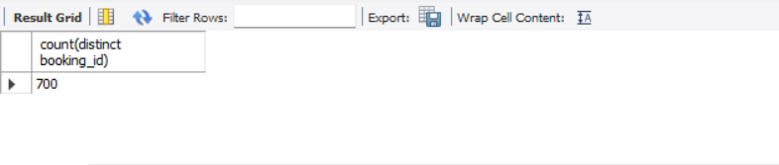

**2. Which meal plan is the most popular among guests?**

**Answer .** select type_of_meal_plan ,count(type_of_meal_plan) from hotel

group by type_of_meal_plan

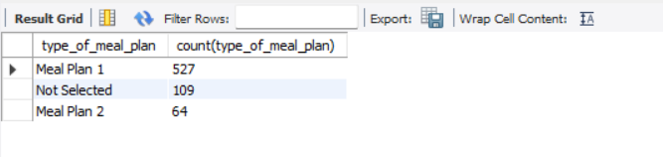

**3. What is the average price per room for reservations involving children?**

**Answer :** select avg(avg_price_per_room) from hotel

where no_of_children > 0 ;

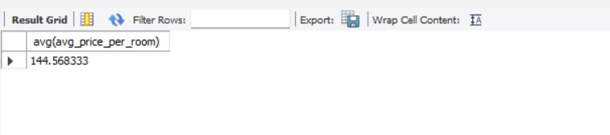**4. How many reservations were made for the year 20XX (replace XX with the desired year)?**

**Answer :**

select count(*) from hotel

where year(arrival_date) =2018 ;

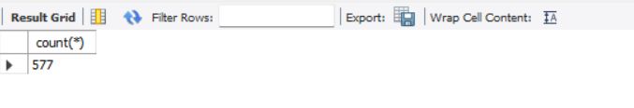

**5. What is the most commonly booked room type?**

**Answer :**

select count(room_type_reserved) ,

room_type_reserved from hotel

group by room_type_reserved;

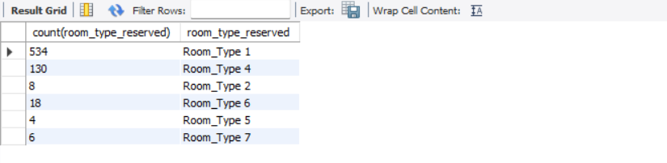

**6. How many reservations fall on a weekend (no_of_weekend_nights > 0)?**

**Answer:**

select count(booking_id) from hotel

where no_of_weekend_nights > 0

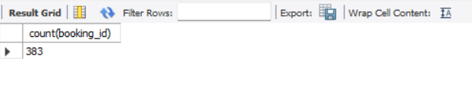

**7. What is the highest and lowest lead time for reservations?**

**Answer:**

select min(lead_time) , max(lead_time) from hotel

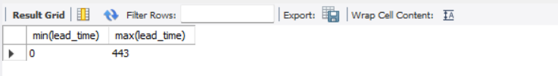

**8. What is the most common market segment type for reservations?**

**Answer :**

select market_segment_type , count(market_segment_type)

from hotel

group by market_segment_type;

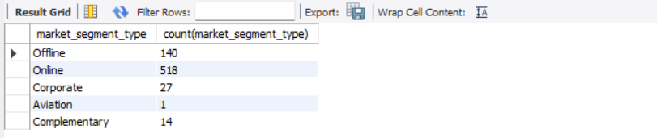

**9. How many reservations have a booking status of "Confirmed"?**

**Answer :**

select count(booking_id) from hotel

where booking_status = "Not_Canceled";

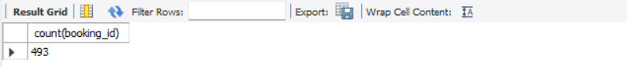

**10. What is the total number of adults and children across all reservations?**

**Answer :**

select sum(no_of_adults) + sum(no_of_children) from hotel

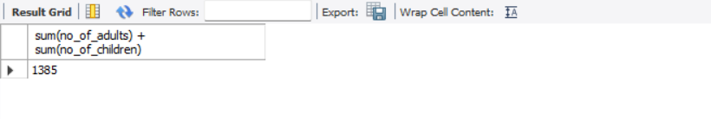

**11. What is the average number of weekend nights for reservations involving children?**

**Answer :**

select avg(no_of_weekend_nights) from hotel

where no_of_children>0;

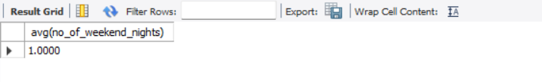

**12. How many reservations were made in each month of the year?**

**Answer :**

SELECT

MONTH(arrival_date) AS reservation_month, year(arrival_date) AS reservation_year,

COUNT(*) AS total_reservations FROM hotel

GROUP BY reservation_month,reservation_year

ORDER BY reservation_month,reservation_year

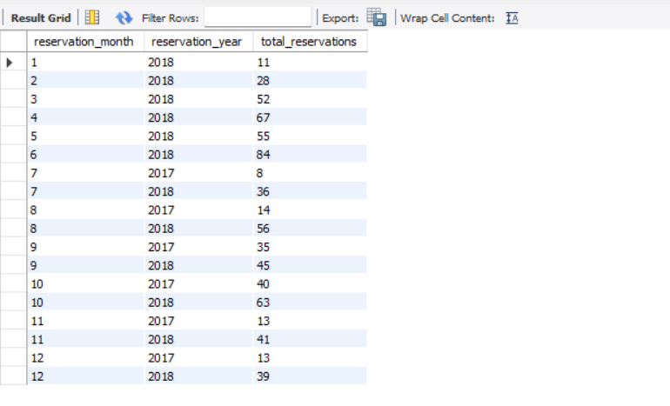

**13. What is the average number of nights (both weekend and weekday) spent by guests for each room**

**Type?**

**Answer :**

SELECT room_type_reserved, AVG(no_of_weekend_nights + no_of_week_nights) AS avg_nights

FROM hotel

GROUP BY room_type_reserved;

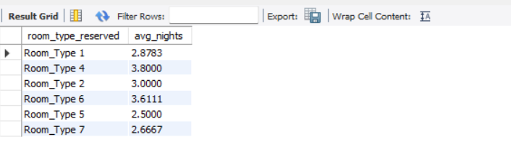

**14. For reservations involving children, what is the most common room type, and what is the average price for that room type?**

**Answer :**

select room_type_reserved , avg(avg_price_per_room)

from hotel

where no_of_children >0

group by room_type_reserved

order by room_type_reserved;

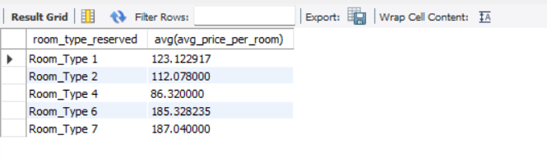

**15. Find the market segment type that generates the highest average price per room.**

**Answer :**

SELECT market_segment_type, AVG(avg_price_per_room) AS avg_price

FROM hotel

GROUP BY market_segment_type

ORDER BY avg_price DESC

LIMIT 1;

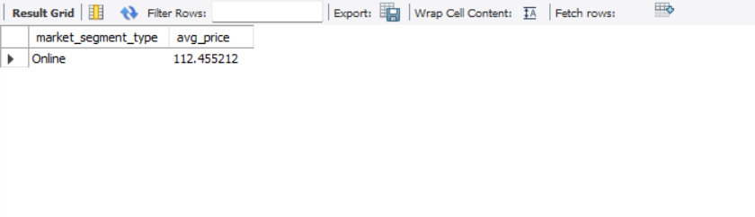

**Thanks for your attention 👏👏👏👏**